Motion lab report
Story:
- There was once a Canadian crossing the border into the United States. Eh?
- He walked ten meters south through the forest in ten seconds.
- When he gets to the river, he stands still for a minute to scopes it out to see if there are any police around.
- Then he swam forty meters south in thirty seconds across the rio Canadia.
- He meets the American police at the border, steals their canoe. Pretty crazy, Eh? Then goes south in a canoe chase.
- He goes 50 meters west through rapids in 10 seconds.
- Then gradually slows down and has fire fight for 50 meters south in 20 seconds. 130
- In the firefight, he gets shot so instinctual heads north to Canada for their free healthcare. At first he is full of adrenaline and swims fast (3m/1sec), but then due to loss of blood starts to swim slower (2m/1sec) and slower(1m/1sec) all of which takes place over sixty seconds.

Purpose: To familiarize the students with using a motion detector and graphing a position vs. time graph.
Procedure:
1. The student must come up with a short story which describes the motion of an object through time.
2. Then the students need to sketch a graph of how the object will behave through time.
3. Then the student needs to mimic the graph that was being sketched using the lab quest and a motion detector.
4. Import the data to logger pro and view data and results.
Data: the Graphs and table are the data
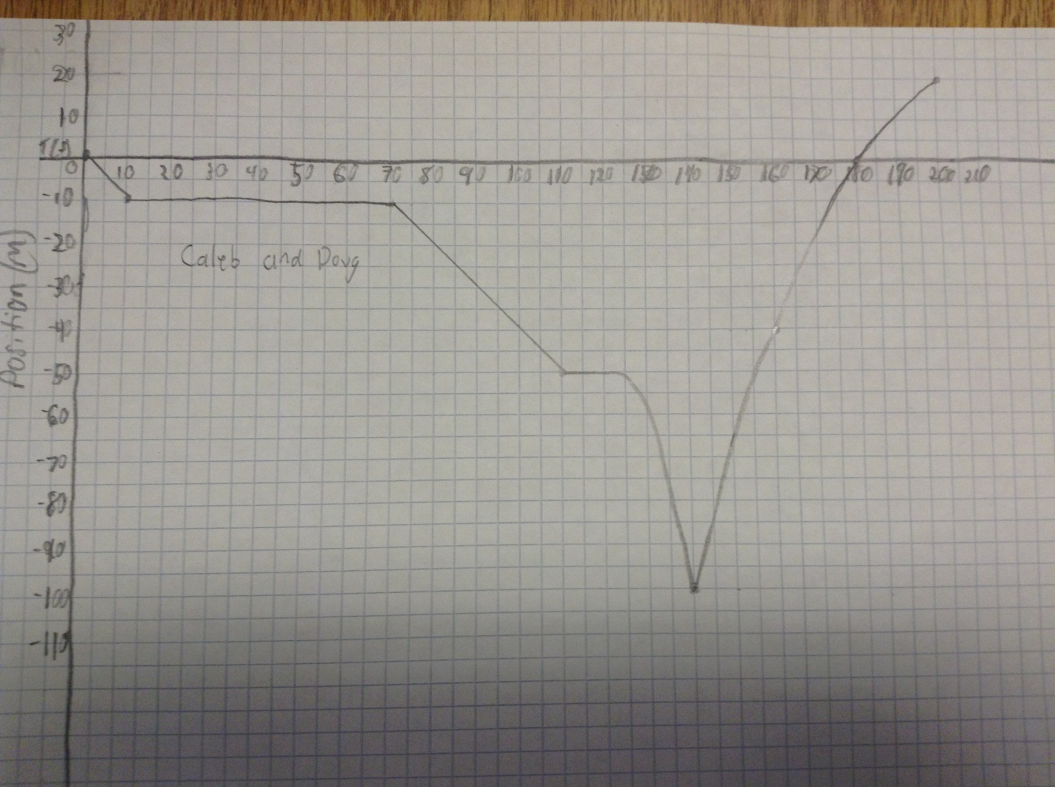
Conclusion: I was able to use the motion detector to make a graph that somewhat resembles the graph that we drew. We realized that there could not be an instantaneous change in position, like the one at the dipping point in the graph.

0 1.227 -0.033 -0.042
0.05 1.225 -0.034 -0.059
0.1 1.223 -0.037 -0.101
0.15 1.222 -0.041 -0.205
0.2 1.22 -0.056 -0.356
0.25 1.216 -0.077 -0.515
0.3 1.212 -0.103 -0.758
0.35 1.207 -0.15 -1.048
0.4 1.197 -0.21 -1.278
0.45 1.187 -0.283 -1.385
0.5 1.169 -0.357 -1.313
0.55 1.15 -0.418 -1.169
0.6 1.127 -0.47 -1.07
0.65 1.103 -0.522 -0.97
0.7 1.075 -0.583 -0.535
0.75 1.043 -0.596 0.295
0.8 1.013 -0.55 1.062
0.85 0.987 -0.472 1.449
0.9 0.966 -0.385 1.39
0.95 0.949 -0.322 1.043
1 0.934 -0.279 0.613
1.05 0.922 -0.259 0.16
1.1 0.91 -0.268 -0.188
1.15 0.896 -0.286 -0.366
1.2 0.881 -0.306 -0.483
1.25 0.866 -0.336 -0.563
1.3 0.847 -0.362 -0.659
1.35 0.829 -0.392 -0.882
1.4 0.81 -0.459 -0.899
1.45 0.783 -0.51 -0.39
1.5 0.756 -0.505 0.286
1.55 0.731 -0.467 0.713
1.6 0.709 -0.419 0.81
1.65 0.69 -0.381 0.723
1.7 0.671 -0.344 0.533
1.75 0.655 -0.316 0.138
1.8 0.641 -0.329 -0.271
1.85 0.623 -0.358 -0.403
1.9 0.605 -0.377 -0.385
1.95 0.585 -0.39 -0.481
2 0.566 -0.416 -0.737
2.05 0.545 -0.464 -0.988
2.1 0.52 -0.521 -1.121
2.15 0.493 -0.582 -1.126
2.2 0.462 -0.638 -1.001
2.25 0.429 -0.687 -0.737
2.3 0.393 -0.719 -0.297
2.35 0.356 -0.725 0.325
2.4 0.318 -0.692 1.029
2.45 0.285 -0.614 1.56
2.5 0.256 -0.518 1.739
2.55 0.233 -0.43 1.706
2.6 0.214 -0.355 1.755
2.65 0.197 -0.265 1.933
2.7 0.186 -0.143 1.755
2.75 0.185 -0.067 1.162
2.8 0.181 -0.037 0.707
2.85 0.181 -0.005 0.432
2.9 0.182 0.004 0.35
2.95 0.182 0.006 0.861
3 0.181 0.052 2.119
3.05 0.182 0.206 3.55
3.1 0.197 0.451 4.092
3.15 0.229 0.669 3.556
3.2 0.268 0.81 2.877
3.25 0.311 0.923 2.858
3.3 0.359 1.063 3.471
3.35 0.414 1.261 4.117
3.4 0.48 1.547 3.281
3.45 0.577 1.664 0.929
3.5 0.652 1.644 -1.492
3.55 0.749 1.463 -2.775
3.6 0.8 1.259 -1.915
3.65 0.864 1.251 -0.478
3.7 0.925 1.253 0.322
3.75 0.988 1.298 0.678
3.8 1.055 1.337 0.541
3.85 1.121 1.386 -0.162
3.9 1.201 1.31 -0.654
3.95 1.25 1.258 -0.093
4 1.319 1.329 0.02
4.05 1.389 1.301 -0.577
4.1 1.45 1.256 -0.963
4.15 1.514 1.199 -1.319
4.2 1.57 1.132 -1.828
4.25 1.629 1.035 -2.57
4.3 1.679 0.84 -2.684
4.35 1.708 0.726 -2.079
4.4 1.749 0.667 -1.965
4.45 1.779 0.538 -1.934
4.5 1.801 0.442 -1.37
4.55 1.821 0.393 -0.643
4.6 1.839 0.388 -0.143
4.65 1.859 0.402 -0.157
4.7 1.88 0.398 -0.63
4.75 1.902 0.323 -0.737
4.8 1.912 0.275 -0.107
4.85 1.924 0.312 0.185
4.9 1.936 0.444 -2.159
4.95 1.993 0.171 -5.83
5 1.951 -0.333 -8.351

